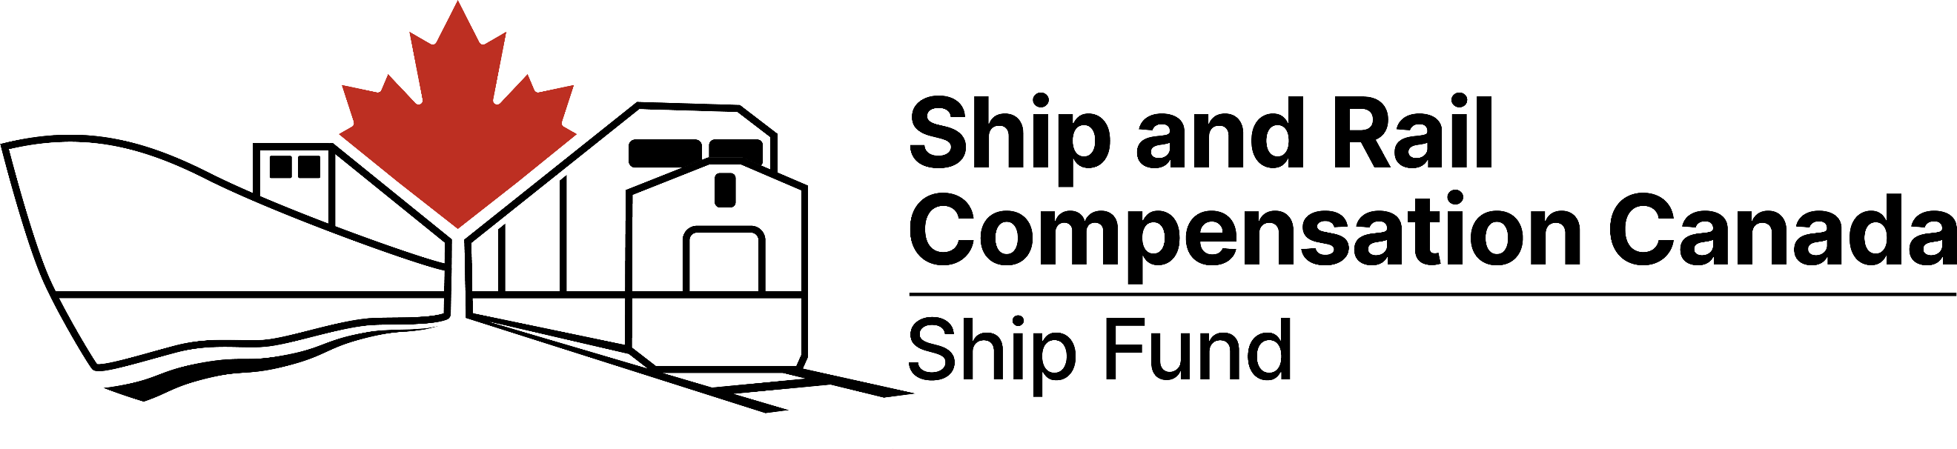

**Compensation After an Oil Spill from a Ship or Boat:**

**Fisheries Checklist**

|  |
| --- |
| * *This checklist is for those working in the fishing sectors, aquaculture, and related activities. Incorporating the suggested steps below directly into your response can simplify the claims process afterward.* |

Ship and Rail Compensation Canada manages two funds: the Ship Fund and the Rail Fund.

The [Ship Fund](http://www.ship-rail.gc.ca/ship) compensates anyone affected by oil spills from ships or boats in Canadian waters.

**1. What criteria must be met for the Ship Fund to accept your claim?**

|  |  |  |
| --- | --- | --- |
| A. Was the oil spill caused by a ship or boat?   * Mystery spills can also be compensated when the source of a spill is not clear. | Yes | No |
| B. Claims are submitted within two years of the incident. | Yes | No |

If you answered “yes” to both questions, compensation may be available from the Ship Fund. If you are unsure, you should contact us.

* More information on our eligibility criteria can be found on our website.

**2. What types of damages and losses are covered?**

Fishers and aquaculturists can be compensated for all of the following damages and losses.

One claimant can suffer multiple types of damages and losses—check all that apply:

Response and clean-up costs

* Examples: Usage of sorbent materials, spill kits, or oil boom

Environmental measures

* Examples: Restoration projects to repopulate an affected fishing area; post-spill environmental monitoring

Property damage

* Examples: Oil-contaminated equipment, catch, stock, or other produce

Economic loss (including future losses)

* Examples: Lost wages or profits caused by fisheries closures, reduced yields, or decreased demand

Subsistence losses and some cultural losses

* Examples: Cost of the replacement of fish or animal skins

Costs to compile a claim

Other: contact us to discuss further.

**3. How to claim?**

|  |  |  |
| --- | --- | --- |
| **Steps** | **Description** | **Step Status Update (complete, in progress, or pending)** |
| 1 | Document your damages, losses, expenses and/or costs, as well as decisions you have made, as soon as possible. Ideally, this is part of your incident management process. Examples include:   * contracts, statements of work, price quotes, invoices, and receipts * details of your fishing or harvesting rights (e.g., license or constitutional right) * financial records and tax documentation * sales predictions, contracts, or quotas * fishing or harvesting yield data for comparison purposes * appraisals, assessments, and survey reports * photographs and maps * incident action plans, logbooks, and correspondence |  |
| 2 | Before you submit your claim, ensure it addresses the following key points. Look for [our forms and manuals](https://ship-rail.gc.ca/ship/submit-claim#how-submit) on our website for additional help.   * Identify the ship or boat that caused the incident, or note that the source of the spill is not known. * Describe the actions you took in response and why. * Detail the extent of the damage and/or losses you incurred. * Specify the amount you spent and why. * Provide evidence to support your claim (see Step 1). |  |
| 3 | Submit your claim by email or by mail to us. |  |